### A Comprehensive Analysis of Financial Performance: Insights from a Leading Banks

# 1.INTRODUCTION

* 1. **OVERVIEW**

The banking industry world-wide is being transformed. The global forces for change include technological innovation; the deregulation of financial services at the national level and opening-up to international competition; and - equally important - changes in corporate behavior, such as growing disintermediation and increased emphasis on shareholder value.

* 1. **PURPOSE**

In this project we are trying to analysis the bank related data and able to extract some insights from the data using Business Intelligence tools. To Extract the Insights from the data and put the data in the form of visualizations, Dashboards and Story we employed Tableau tool.

# 2.PROBLEM DEFINITION & DESIGN THINKING

**2.1 Emapthy Map**

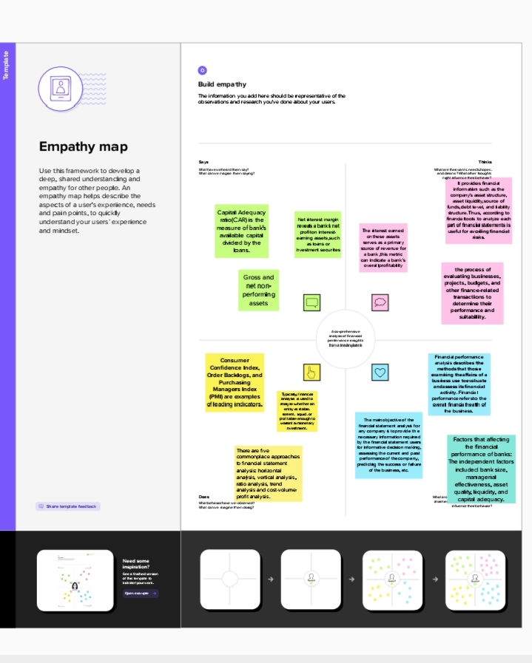

**2.2 Ideation& Brain Storming Map**

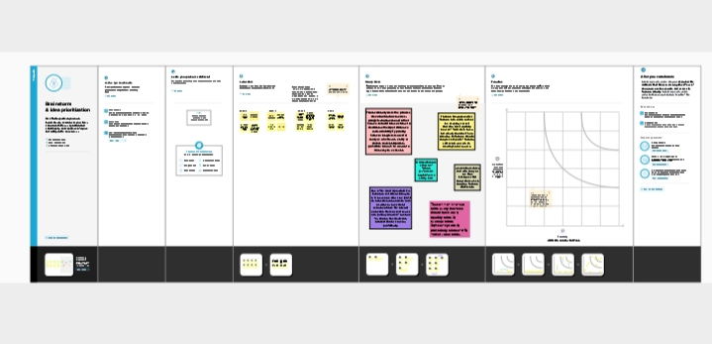

# Result

Financial analysis of banks can have a significant impact on the business operations of the bank itself and its competitors. This information can then be used to develop strategies for improving the bank's performance, such as by reducing costs, increasing revenue, or improving risk management practices.

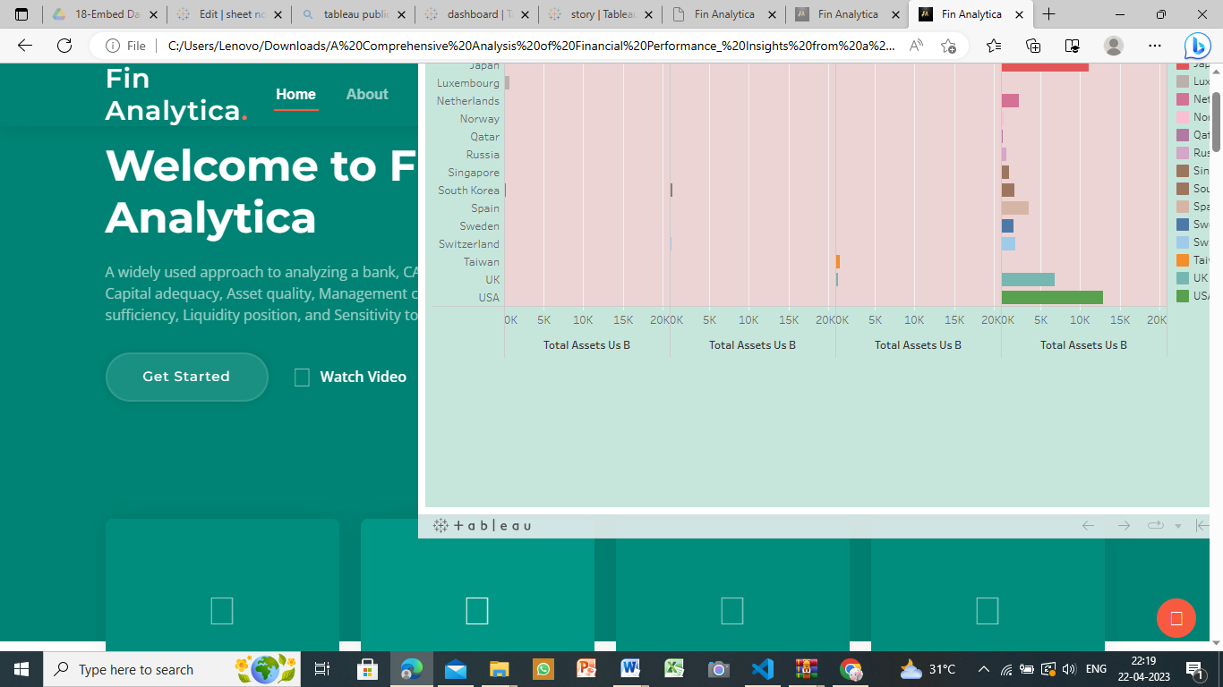

# ADVANTAGES & DISADVANTAGES

The visual or pictorial representation of banks provides financial information in easily understandable way such as the company's asset structure, asset liquidity, source of funds, debt level, and liability structure. Thus, according to financial tools to analyse each part of financial statements is useful for avoiding financial risks.

The financial analysis does not contemplate cost price level changes. The financial analysis might be ambiguous without the prior knowledge of the changes in accounting procedure followed by an enterprise.

# APPLICATIONS

* Data visualization is the graphical representation of insights generated in real-time. The reports are used by banks to effectively streamline daily activities and make faster decisions. Data visualization is the process of graphically visualizing large data sets.
* Analytics can be used to identify and rate individual customers who are at risk of fraud and then apply different levels of monitoring and verification to those accounts. Analysing the risk of the accounts allows banks and financial institutions to know what to prioritize in their fraud detection efforts.
* Data visualization helps to tell stories by curating data into a form easier to understand, highlighting the trends and outliers. A good visualization tells a story, removing the noise from data and highlighting useful information.

# CONCLUSION

Good data visualization should communicate a data set clearly and effectively by using graphics. The best visualizations make it easy to comprehend data at a glance.

# FUTURE SCOPE

* In the future, big data analytics will increasingly focus on data freshness with the ultimate goal of real-time analysis, enabling better-informed decisions and increased competitiveness.
* Another common career path for data analysts is to move into management positions. You might start out as a data analyst before advancing to senior-level analyst, analytics manager, director of analytics, or even chief data officer (CDO).

# Appendix

Fin Analytica

A%20Comprehensive%20Analysis%20of%20Financial%20Performance_%20Insights%20from%20a%20Leading%20Banks-20230422T152228Z-001/A%20Comprehensive%20Analysis%20of%20Financial%20Performance_%20Insights%20from%20a%20Leading%20Banks/index.html